Features required by Clinic Management System
In a clinic management system, five functions are required within the system. The first function is patient management. Patient management is used to add new patients. This is necessary because there are always new patients coming in at the clinic, and patients can be used to add patient information to the management system. Additionally, for patients, there are edit and delete functions to handle necessary changes that may occur, such as those that are wrong information about patient details and delete is used to remove patient information.

The second function is Appointments, which is used to create appointments for patients. Using a clinic management system, information can be systematically saved and appointments created for patients. Additionally, like the patient function, it can be used for editing and deletion to tolerate errors and changes during the creation phase.

The third function is prescription, which stores patient and drug information. This is important because the patient's medication information needs to be stored in case the patient requires a higher dose of the medication. The fourth function is Discharge, which is used to bill the patient after the appointment. Unlike other functions, Discharge does not have a delete function as the saved data must not be lost within the database.

Finally, there is the admin panel, which can only be accessed by administrators of the clinic management system. This feature is used to add users to the management system and their access levels to the system. For a clinic management system, administrators can add, delete, and edit account information, while receptionists can only access the other four functions because users can only be managed by administrators.

Database
Table 2 . 1 Database of Clinic Management System
Table | Function
Patient | Patient table is used to store in patient information on the system by using values such as patientID, PatientName, contact, and address.
Appointment | Appointment is used to track for the appointment id and the doctor that is conducting the appointment this table uses data such as patientname, appointment id, and doctor name.
Prescription | Prescription is used to keep track of the patient medicine list.
Billing | Billing is used for billing on the patient.
Users | Users is used to define the access level of a certain users to the management system, the values inside users is ID, Password, and privilege in the management system 1 refers to the administrator while 0 refers to the receptionist.

The core PHP scripts and libraries
PHP is a server-side scripting language used to create dynamic web pages, while MySQL is a relational database management system used to store and retrieve data. Also, XAMPP is a very popular PHP development environment for Windows, Mac OS X and Linux platforms. It is a free and easy-to-install Apache distribution that includes MariaDB, PHP and Perl. The purpose of XAMPP is to provide a simple installation method that allows developers to create a web server with all necessary services in a local environment.

So, we will use XAMPP software for local development which suite provides an Apache server, MySQL, PHP and PhpMyAdmin. Eventually we will create the MySQL database that belongs to our project, using PhpMyAdmin and the MySQL command line tool to create a new database for the project.
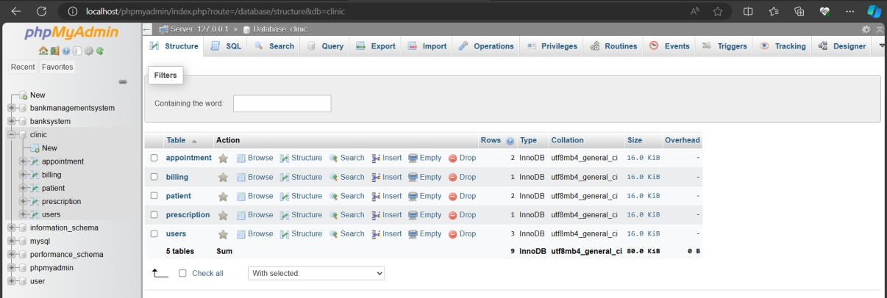

Figure 3.1 Clinic Management System in MySQL

Interface Design
Design will be using minimalistic and simple is because the system uses less performance to run. Extra design is not going to help the system as more detail can slow it down.

Log In page
This is the log in page where users are required to access the system.

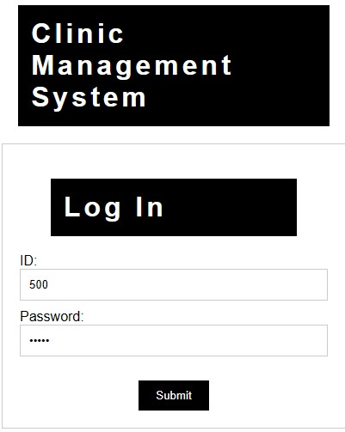

- ID need to be numeric.
- Password is hidden among the users.
- Submit button validate the user’s information.

Figure 4.4.1 A login Page

Main Menu
Main Menu have a navigation menu and a Logout button.

Table 4.2 A table for Main menu navigation function
Log Out | Log the users out the session
Patient | View and Manage the Patient table
Appointment | View and Manage the Appointment table
Prescription | View and Manage the Prescription table
Billing | View and Manage the Billing table
Admin Panel | Only Admin can View and Manage the Admin Panel table.  Otherwise, receptionist or staff will be redirected to Patients table

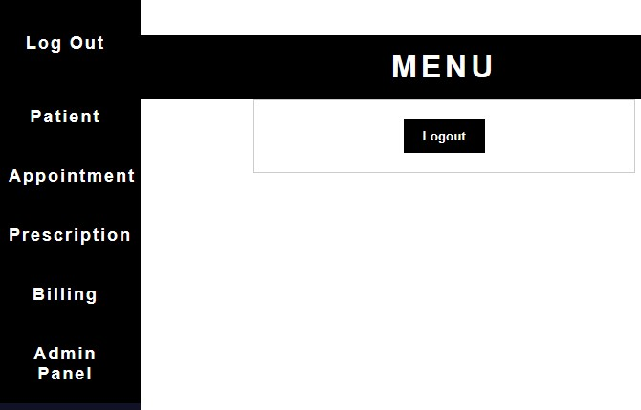
Figure 4.2 Figure 4.2 An image for Main menu

Patient
Patient pages allow users to ADD, EDIT and DELETE the prescription data.
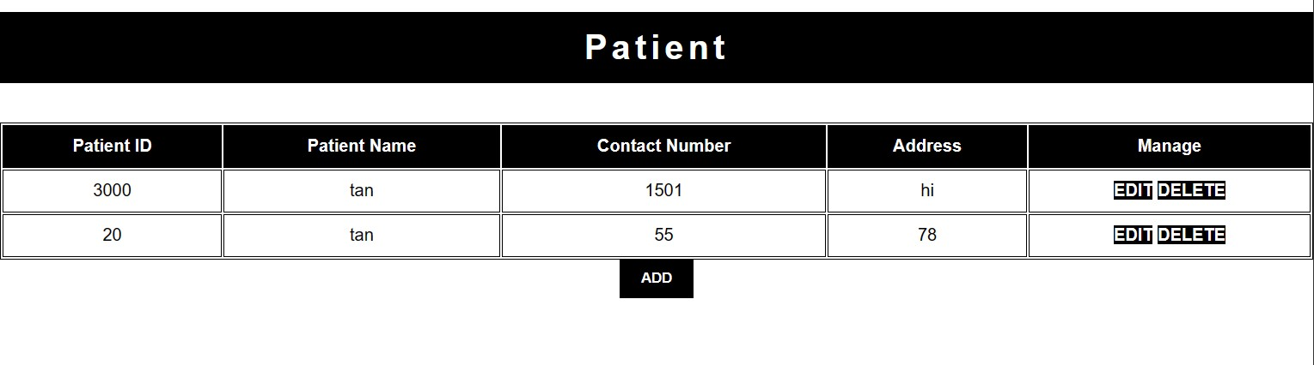

Figure 4.3 Patient Table

EDIT OR
DELETE
Data

ADD
Data

ADD |  | EDIT
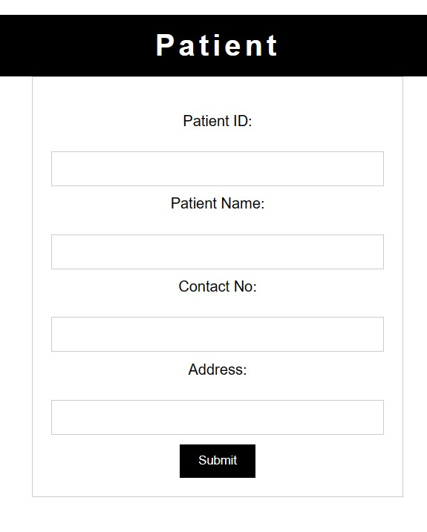
- PatientID only can be numeric.
- User can insert data by typing into the textbox.
- All textbox need to be filled to prevent inserting missing data.
- Submit button will Insert the data into database.
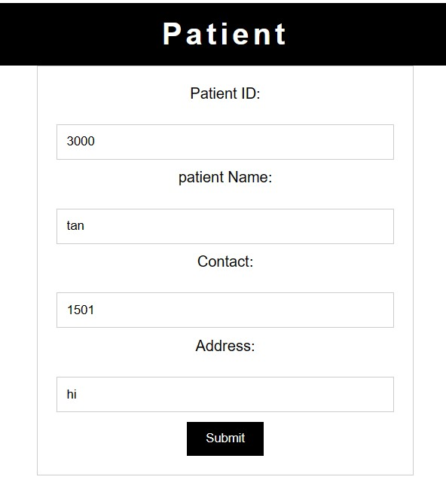

- User can edit data that is taken from the database.
- PatientID textbox is disabled to ensure the user is changing the correct data.
- Edit button will update the data into database.

DELETE
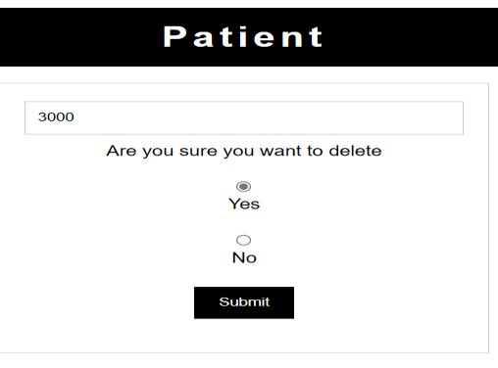
- User can delete data that is collected from the database.
- Delete button will delete the data row of the ID.
Figure 4.3 Picture and guides of Prescription form with ADD, EDIT and DELETE pages

Appointment
Appointment pages allow users to ADD, EDIT and DELETE the appointment data.

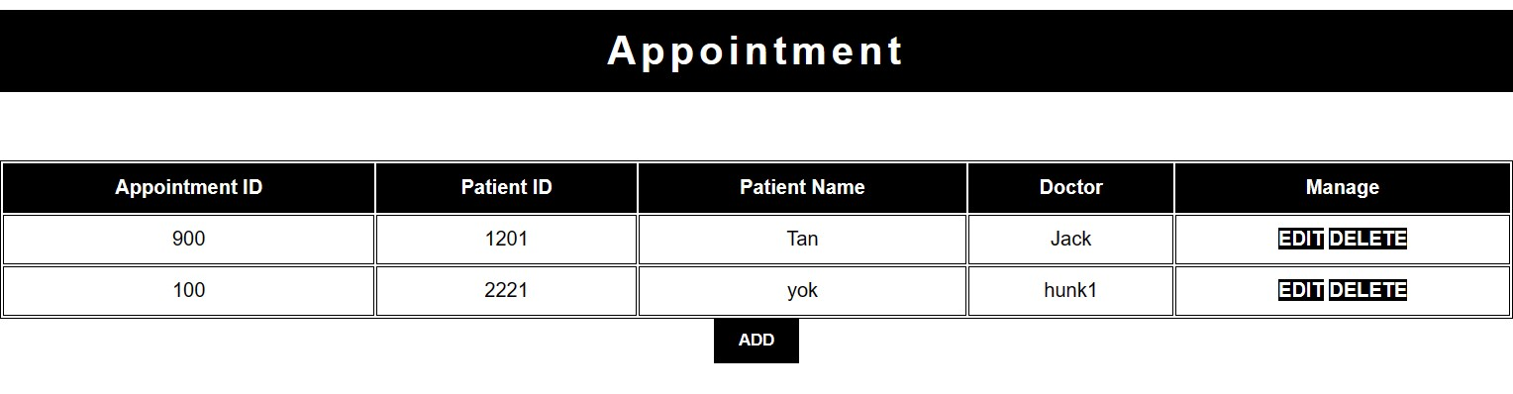

Figure 4.4 Appointment Table

EDIT OR
DELETE
Data

ADD
Data

ADD |  | EDIT
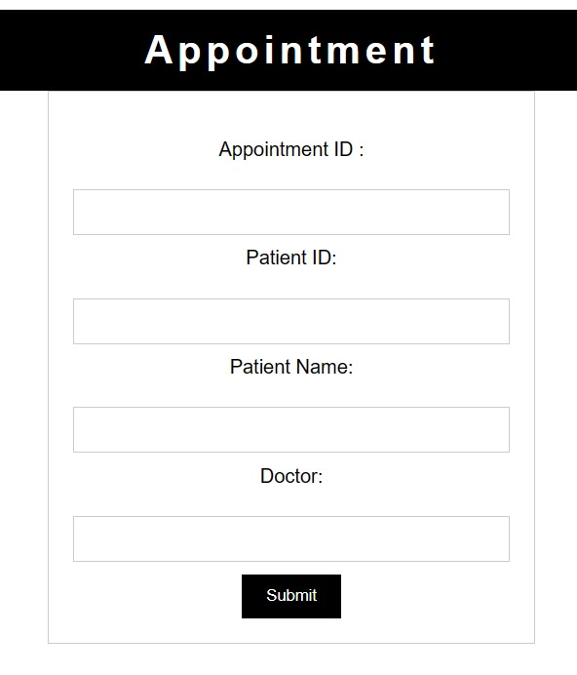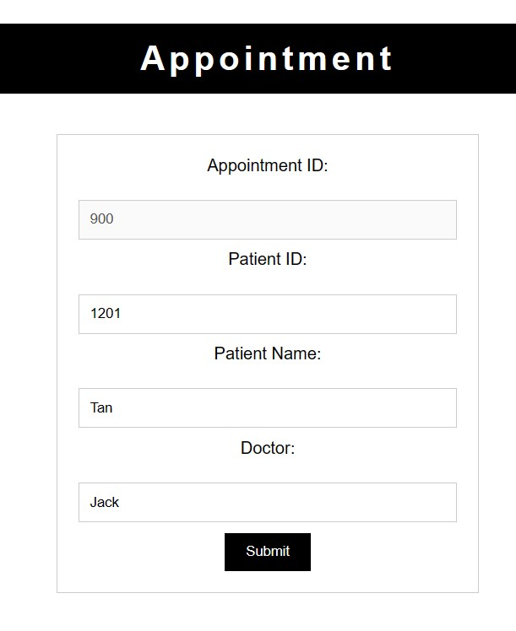

- AppointmentID only can be numeric • User can edit data that is taken

data. from the database.
- User can insert data by typing into the • AppointmentID textbox is disabled textbox. to ensure the user is changing the
- All textbox need to be filled to prevent correct data.

inserting missing data. • Edit button will update the data
- Submit button will Insert the data into into database. database.

DELETE

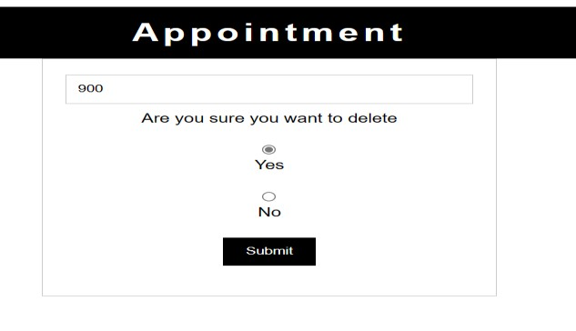
- User can delete data that is collected from the database.
- Delete button will delete the data row of the ID.

Figure 4.4 Picture and guides of Appointment form with ADD, EDIT and DELETE pages

Prescription
Prescription pages allow users to ADD, EDIT and DELETE the prescription data.

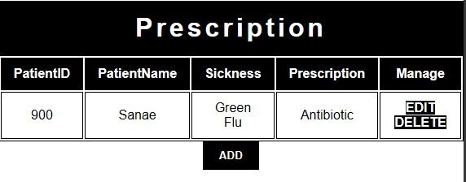

Figure 4.5 Prescription Table

ADD
Data

EDIT OR
DELETE
Data

ADD |  | EDIT
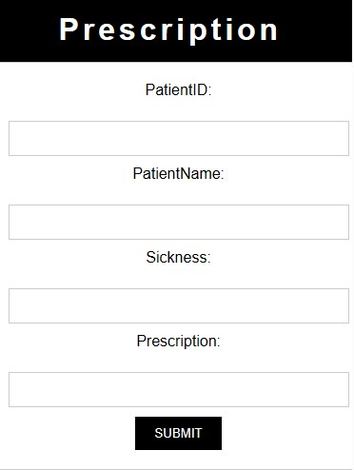
- PatientID only can be numeric.
- User can insert data by typing into the textbox.
- All textbox need to be filled to prevent inserting missing data.
- Submit button will Insert the data into database.
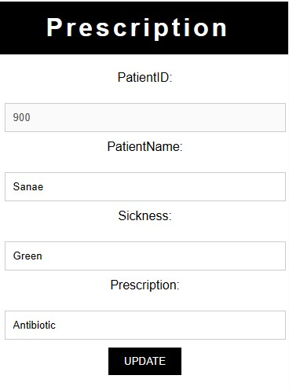

- User can edit data that is taken from the database.
- PatientID textbox is disabled to ensure the user is changing the correct data.
- Edit button will update the data into database.

DELETE
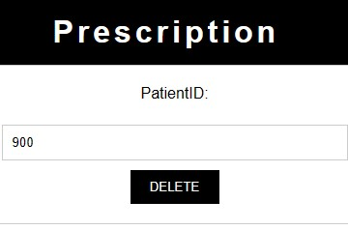
- User can delete data that is collected from the database.
- Delete button will delete the data row of the ID.
Figure 4.5 Picture and guides of Prescription form with ADD, EDIT and DELETE pages

Billing
Billing pages allow users to ADD, EDIT and DELETE the billing data.

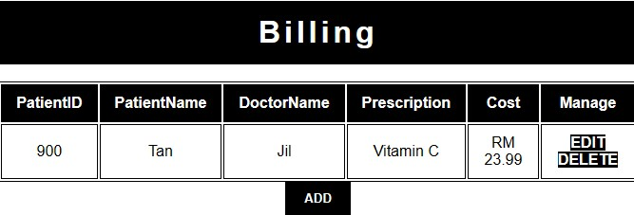
ADD
Data

EDIT OR
DELETE
Data

Picture of Billing table

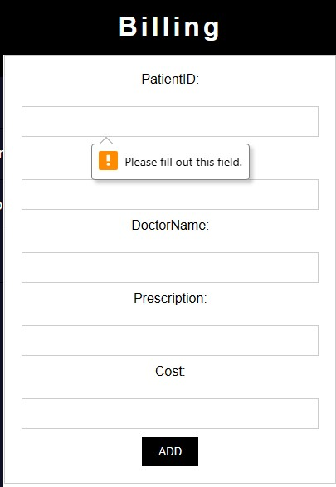
ADD |  | EDIT
- PatientID only can be numeric data.
- Cost only can be float data.
- User can insert data by typing into the textbox.
- All textbox need to be filled to prevent inserting missing data.
- Submit button will Insert the data into database.
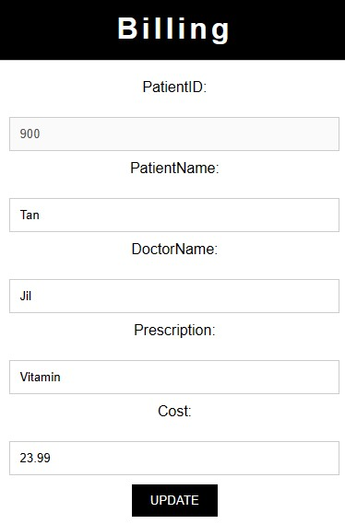
- User can edit data that is taken from the database.
- PatientID textbox is disabled to ensure the user is changing the correct data.
- Edit button will update the data into database.

DELETE
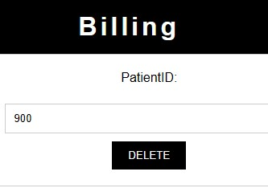
- User can delete data that is collected from the database.
- Delete button will delete the data row of the ID.
Figure 4.6 Picture and guides of Billing form with ADD, EDIT and DELETE pages

Admin panel
Admin panel is used to manipulate operator account and administrator of the management system
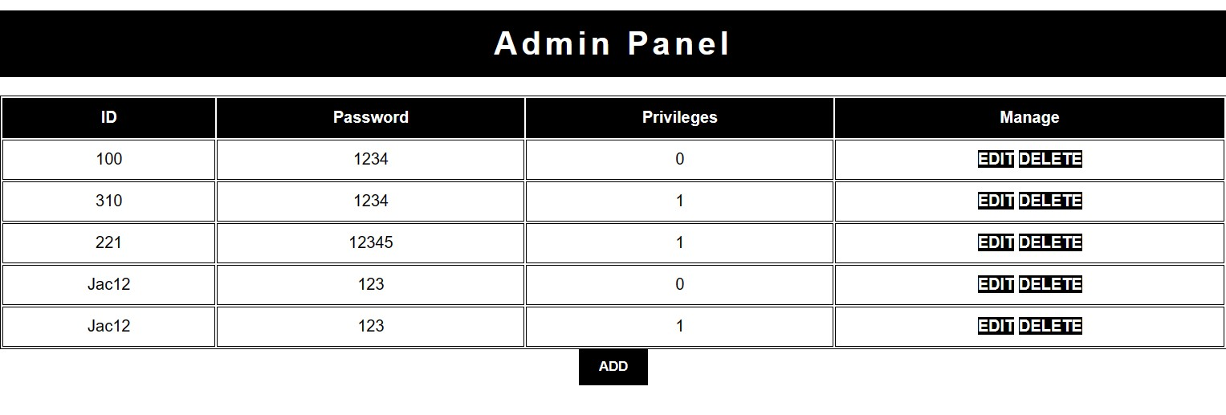

Figure 4.7 Admin Panel Table

ADD
Data

EDIT OR
DELETE
Data

- The column in the management panel is the ID used by the staff, the password is the account password, and the permissions are whether users in the management system can access the management panel.

- 0 is a normal user, which is the receptionist.

- 1 Consult your administrator.

- Although the administrator can change the user account of the user receptionist who does not have access to the admin panel, they will be redirected to the patient table.

ADD |  | EDIT
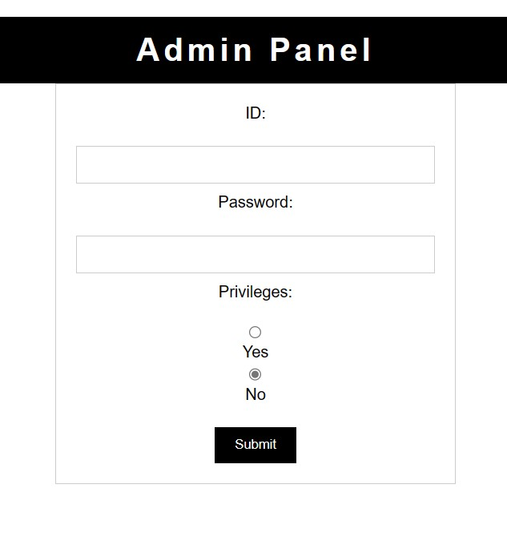
- User can insert data by typing into the textbox.
- All textbox need to be filled to prevent inserting missing data.
- Submit button will Insert the data into database.
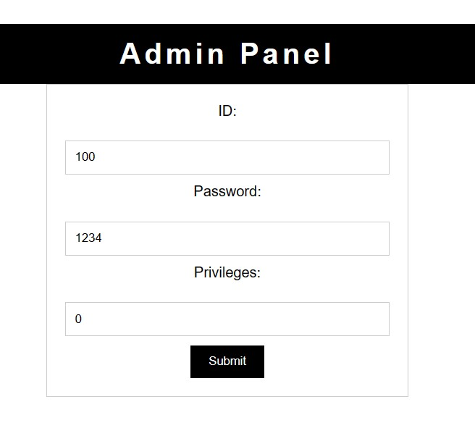
- User can edit data that is taken from the database.
- textbox is disabled to ensure the user is changing the correct data.
- Edit button will update the data into database.

DELETE
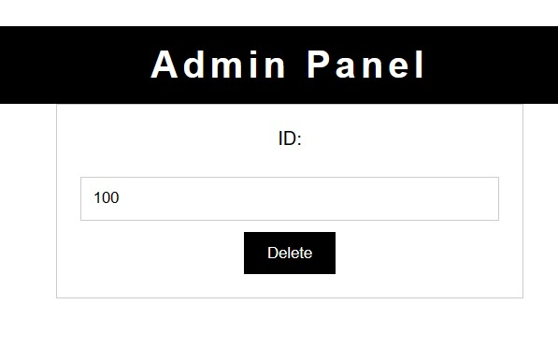
- User can delete data that is collected from the database.
- Delete button will delete the data row of the ID.
Figure 4.7 Picture and guides of Prescription form with ADD, EDIT and DELETE

